Instructions on Manuscript Preparation for the Book of Abstracts
Ichiro Suzuki^{1,2}, Hanako Tanaka², Thomas A. Edison ^{1,2,3}
¹ Life Science Laboratory, Japanese Mass Spectrometry Co., Japan
² Institute of Mass Spectrometry, Japan
³ Graduate School of Engineering, University of Mass Spectrometry, Japan

Keywords: Instructions, Conference, Mass Spectrometry, Abstract, Preparation

This is the form for preparing a manuscript of your abstract submitted to the International BMS Symposium. The page margins of your word processor must be set to 25 mm.
Please prepare your manuscript within one page length of A4 sheet. Exceeding one page, only the first page will be published in the book of abstracts. Since the abstract will be printed in black-and-white pages, do not use colored figures or characters. It may happen that the book of abstracts will be issued before the symposium dates.
Times New Roman font is recommended. First, please enter title, author’s names, and affiliations. Font size of the title is 12 pt in bold. Font size of author’s names is 10 pt. Each name must have a superscript notation of the corresponding affiliation number, and be delimited with a comma “,”. The presenting author must be indicated by underline. Font size of author’s affiliations is 10 pt in italic. The affiliations must be numbered with superscript notations and delimited with a line break between each affiliation.
Change paragraph, then type “Keywords:” and indicate keywords (up to 5), whose font size is 10 pt. Font size of the main text is 10 pt. Identify references¹⁾ in the text by using superscript notations. There is no restriction of styles of figures and tables, except they need serial numbers and titles.

Your manuscript must be submitted in the format of PDF. To ensure that the electronic version matches the print version, all fonts used must be embedded within a PDF file. To embed the fonts, select the Press Quality option in Adobe Acrobat. In Microsoft Word, select “Standard (publishing online and printing [Windows]” or “Best for printing [Mac]” after selecting PDF in the Save As menu. Please keep the file size less than 3 MB.

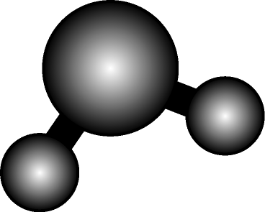

Fig.1. Schematic diagram of H₂O molecule

References
- The character size is 10 pt. The following format is recommended.
- J.S.Brodbelt et al., Mass Spectrom. Rev., 16, 91-110 (1989).

