英語表記した質量分析総合討論会の講演要旨集用原稿について（日本人用）
（日本質量分析株式会社¹・質量分析研究所²・質量分析大学³）
鈴木一郎^{1,2}・○田中花子²・ A Edison^{1,2,3}
Instructions on Manuscript Preparation for the Book of Abstracts (For Japanese)
(Japanese Mass Spectrometry Co.¹, Institute of Mass Spectrometry², University of Mass Spectrometry³)
I.Suzuki^{1,2}, ○H.Tanaka², T.A.Edison ^{1,2,3}
Keywords: Instructions, Conference, Mass Spectrometry, Abstract, Preparation
This is the form for preparing a manuscript of your abstract submitted to the Annual Conference on Mass Spectrometry. Japanese authors are encouraged to prepare their abstracts in English. If you have downloaded the template file in the Microsoft Word document format from the MSSJ website (URL: https://www.mssj.jp), you can prepare abstracts by overwriting the template. Even if you do not overwrite the template, it is strongly recommended that your manuscript be matched with the style of this form. The page margins of your word processor must be set to 25 mm.
Please prepare your manuscript within one page length of A4 sheet. Exceeding one page, only the first page will be published in the book of abstracts. Since the abstract will be printed in black-and-white pages, do not use colored figures or characters.
It may happen that the book of abstracts will be issued before the conference dates. As regards other notes not shown in this instruction, please refer to the MSSJ website at first.
MS Mincho font for Japanese and Times New Roman font for English are recommended. First, please enter title, affiliations, and author’s names in Japanese. Font size of title is 12 pt in bold. Font size of author’s affiliations is 10 pt. The affiliations must be numbered with superscript notations and delimited with a bullet “・” between each affiliation, then enclosed in parentheses. Font size of author’s names is 10 pt. Each name must has “furigana” printed beside and a superscript notation of the corresponding affiliation number, and delimited with a bullet “・”. The presenting author must be indicated by an open circle “○”.
The subsequent paragraphs are a title, affiliations, names in English, follows the styles of Japanese ones. Use comma “,” instead of bullet “・” as the delimiter. Change paragraph, then type “Keywords:” and indicate keywords (up to 5), whose font size is 10 pt. Only the case of the manuscript prepared in English, the English “short abstract” can be omitted. Font size of the main text is 10 pt. Identify references¹⁾ in the text by using superscript notations.
There are no restriction of styles of figures and tables, except they need serial numbers and titles.

Your manuscript must be submitted in the format of PDF. To ensure that the electronic version matches the print version, all fonts used must be embedded within a PDF file. To embed the fonts, select the Press Quality option in Adobe Acrobat. In Microsoft Word, select “Standard (publishing online and printing [Windows]” or “Best for printing [Mac]” after selecting PDF in the Save As menu. Please keep the file size less than 3 megabyte. After submitting your manuscript on-line, you may receive an e-mail notification, which contains instructions to check the appearance of the printed abstract. Please make sure that the appearance matches with your manuscript.

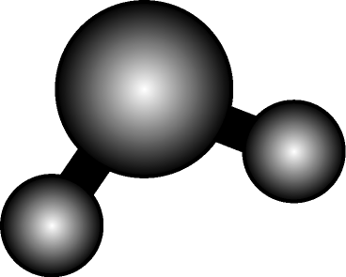

Fig.1. Schematic diagram of H₂O molecule

References
- The character size is 10 pt. The following format is recommended.
- J.S.Brodbelt et al., Mass Spectrom. Rev., 16, 91-110 (1989).

